Interactive Lessons # 2 – The Electric Field and Potential
Physics 2

Instructions: Using a web browser, navigate to the following website: “Charges and Fields”

https://phet.colorado.edu/sims/html/charges-and-fields/latest/charges-and-fields_all.html

Note: If the simulation does not work you can search for PHET simulation in your web browser and access from there.

Learning Objective for this simulation.

- Describe the electric field created by an electric dipole and the corresponding electric potential.
- Analyze and explain what happens to the electric field strength and the electric potential between the charges of a dipole.
- Evaluate the dependence of plate area and spacing on the capacitance of a capacitor.
- Describe how the charge, electric field and electric potential change as a capacitor is charged and then discharged.

Activity # 1: The electric dipole.

- Spend about 5 minutes getting familiar with various options of the Phet simulation. To use the charge and sensors, right click, hold and drag to the workspace. To remove the charge or sensor, right click and drag back to box.

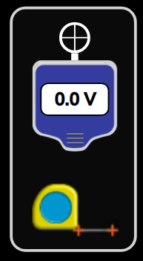
Electric Field sensor
Positive and negative
Point charges
Voltage meter
Tape measure

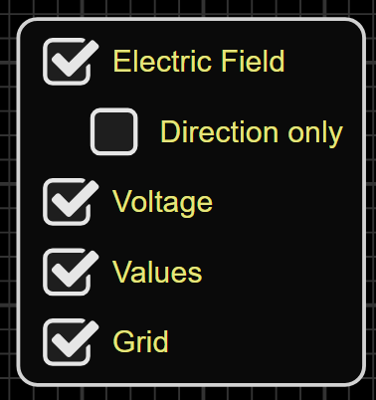

Settings for Field and grid
Reset page

- Electric field and equipotential lines for an electric dipole.

- Reset the workspace and select Electric Field, Voltage, Values and Grid in the settings.
- Using the tape measure set to 600 cm (as close as you can get) to set the distance between the charges. The background grid can help to get the exact points (Each larger grid box is 50 cm). Make sure it is horizontal.

- Drag and drop one positive red charge at the right end of the tape measure at 0 cm mark.
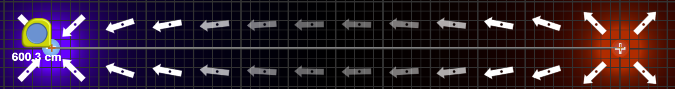
- Drag and drop one negative blue charge at the left end of the tape at the 600 cm mark.

- Starting from the positive charge, create equipotential lines every 50 cm (larger grid boxes) by clicking the pencil on the voltage meter every 50 cm till you reach the negative charge.

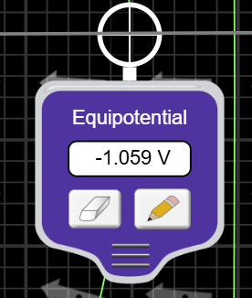
Question: Explain how the electric potential changes along the line between the charges and why this would be the case.

Question: What does the spacing of the equipotential lines tell you about how the electric field strength changes as you move away from the center line (up and down).

Question: Using the yellow Electric field strength sensor, move the sensor up and down along a equipotential line and observe the value of the field. Does this validate the answer above, explain?

- The electric field and the electric potential between charges.

- Using the voltage meter, starting at the positive end, right click, hold and drag (to the left) along a horizontal line to the negative charge noting the readings on the voltage meter.

- Determine the point at which the voltage is zero and leave the voltmeter at the location.
- Using the yellow electric field sensor, repeat step 7 but with the yellow electric field sensor noting the values.


- Move the electric field senor to the location of the zero potential and note the electric field value.

Question: Explain why the electric potential is zero at the location you found and why is it this location between the charges?

Question: Why is the electric field strength not zero at the zero electric potential location, explain?

Question: If the value of the positive charge was doubled what would this do to the location of the zero potential?

Question: Drag and drop a second positive charge on top of the first and find the new zero potential locaiton. Does this verify the answer to the previous question, explain?

- Electric field and potential for three changes along a horizontal line.

Note: Remove the second positive charge from the previous activity before starting this activity.

- With one positive charge at 0 cm and one negative charge at 600 cm, place a second positive charge (third over all charge) at the center (300 cm mark) between the other two charges.

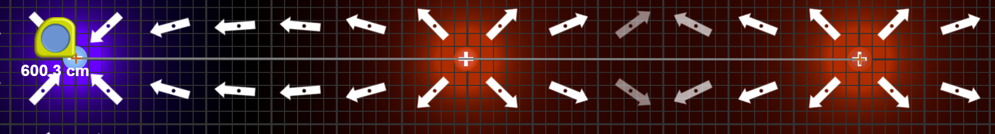
- Using the voltage meter start from the far right positive charge and left click, hold and drag along the horizontal line between each of the charges all the way to the negative charge, noting the value of the voltage as it moves.
- Find if there are any zero potential locations and leave the meter at that location.
- Repeat set 12 but with the yellow electric field senor.

Question: Explain why the electric potential is zero at the location you found?

Question: Explain why the electric field strength is not zero at zero potential?

Question: Explain why the electric field strength is zero at the location you found?

Simulation B: Electric field, charge and electric potential for a capacitor.

Navigate to the PHET simulation “Capacitor Lab:Basics”

Link below

https://phet.colorado.edu/en/simulations/capacitor-lab-basics

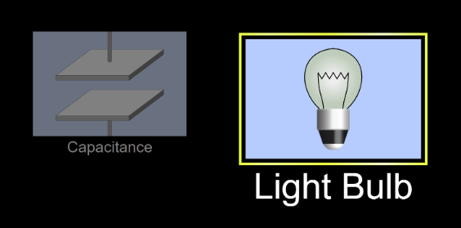

- Click on the “Light Bulb” part of the simulation
- Check all the boxes for the capacitor for both right and left boxes.
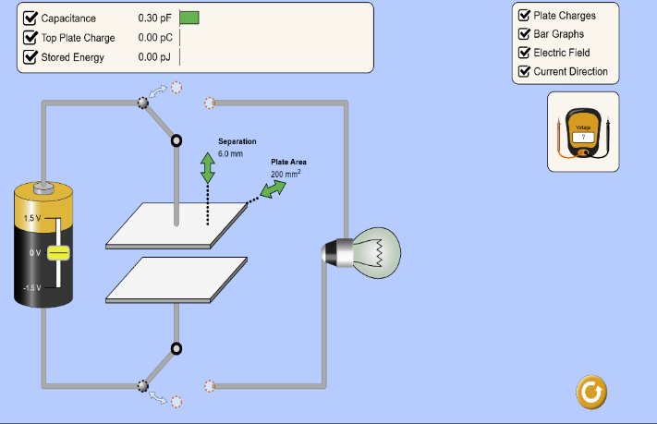

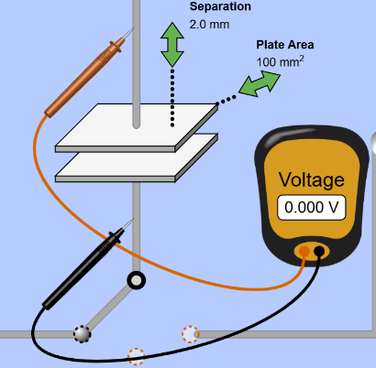
- Connect the voltage meter to the top and bottom plate as shown. (red led on top and black on bottom)

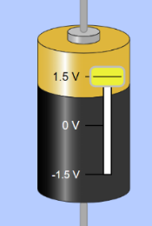
- Set the battery voltage to +1.5 V by right clicking, holding, drag up the yellow bar. Observe what happens to the values and the capacitor.
- Once the capacitor is charged, click hold and drag the “Separation” of the plates (green arrow) and observe what happens to the values in the top box, voltmeter and the capacitor.
- Click hold and drag the “Plate Area” of the plates (green arrow) and observe what happens to the values in the top box, voltmeter and the capacitor.
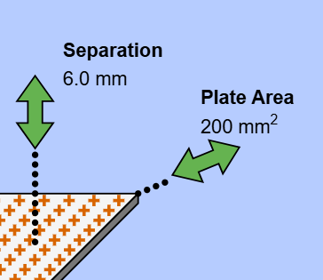
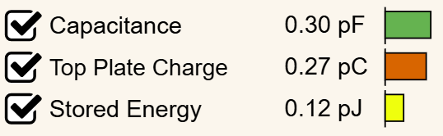

Question: How does changing the separation of the plate change the capacitance, amount of charge and stored energy of the capacitor?

Question: How does changing the separation of the plates change the electric field strength between the plates and voltage across the plates, explain?
Question: How does changing the area of the plate change the capacitance, amount of charge and stored energy of the capacitor?

Question: How does changing the area of the plates change the electric field strength between the plates and voltage across the plates, explain?

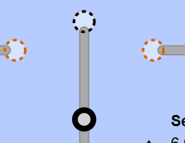
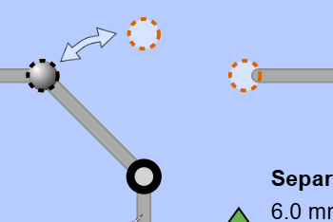
- With the capacitor back to the separation of 2 mm and the plate area of 100 mm² and battery set at 1.5 V, move the switch to the center pole and observe what happens when the switch is moved to the center.

Question: What happens to the capacitance, charge, storge energy and voltage across the plate when the switch is at the center pole?

- With the switch at the center pole (no battery connected to the capacitor), click hold and drag the “Separation” of the plates (green arrow) and observe what happens to the values in the top box, voltmeter and the capacitor.
- Click hold and drag the “Plate Area” of the plates (green arrow) and observe what happens to the values in the top box, voltmeter and the capacitor.

Question: How does changing the separation and area of the plates change the electric field strength between the plates and voltage across the plates, explain?

Question: Why would the charge not change but the voltage and electric field strength change as the capacitor is changed?

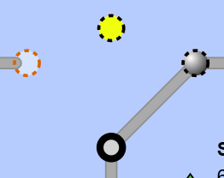
- With the capacitor back to the separation of 2 mm and the plate area of 100 mm², move the switch to the right pole and observe what happens when the switch is moved to the right pole.

Questions: Explain what happens to the charge and voltage across the capacitor when the switch is moved to the right.

Question: Explain why the bulb gets dimmer in terms of the voltage across the capacitor.

- Move the switch back to the left pole.
- With the switch at the left pole move the battery voltage down to negative 1.5 volts, all the way down to the bottom of the battery.
- Move the switch to the right pole and observe what happens.

Question: What changes and what does not change when the capacitor is discharged with a negative voltage?

- When complete and Upload this Lesson to this Canvas assignment.

